# Reports Data Source Preparation Guideline

1. In JIRA, indicated the main parameters for the report

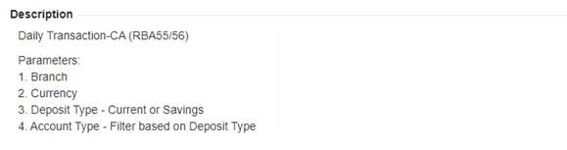

1. Get the sample report from User Guide and indicate the SELECT statement (Can use PPT, Word, Excel…format does not really matter as long as the requirements are clear).

Prepare a working SELECT statement based on current CBS9 schema (without parameter filtering). Once the SELECT statement is working, add the filtering in the WHERE clauses so that Reports developer would know exactly the placement, especially beneficial for more complex joins.

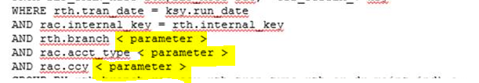

In Daily Transaction RBA55/56 report, it calls a separate Stored Procedure to prepare the data in a temporary table. Upon checking the stored procedure, we can implement the report without the need for temporary table (the old approach creates overhead to delete the temp table and creating data in it).

So if there are reports calling a stored procedure to prepare the report data, need to examine it if we can streamline.

Do not create a dedicated view just for the report.

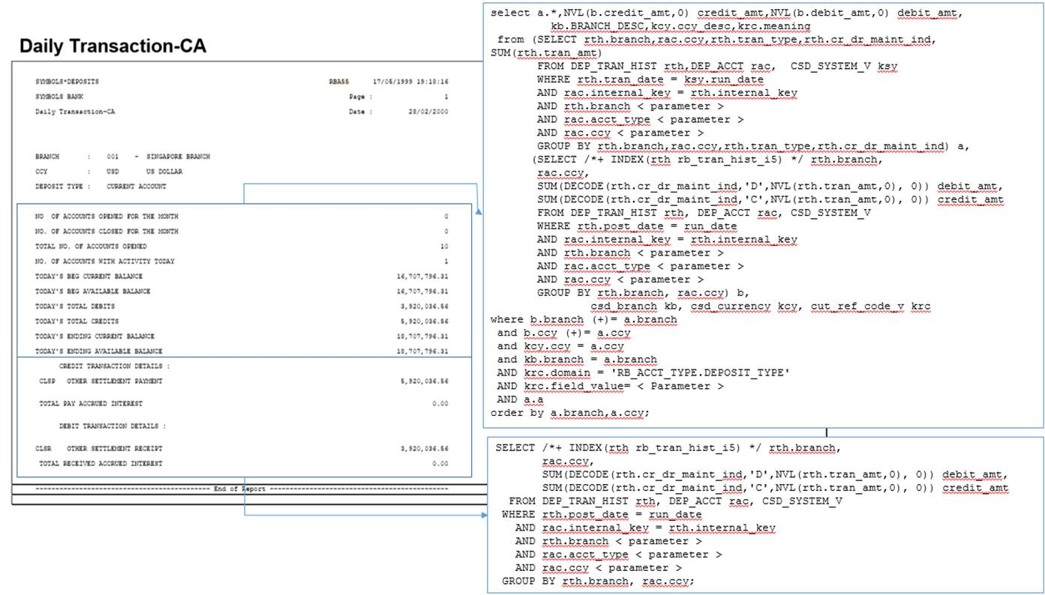

1. In CBS9, we are not going to use BETWEEN Where clause all the time (like in 8.6). We will only use it when applicable. BETWEEN where clause is only applicable when filter value is RANGE (sequential in nature like Date) but not applicable for filters like Currency as the values are not logically sequenced. We will handle it differently so it is enough to indicate it as parameter in the SELECT statement. The Jasper developer will already know what to do with it.  
     
   For more info on filters, you can visit link below.

<https://silverlakeaxisltd.sharepoint.com/Silverlake%20Symmetri%20Core%20Banking/SitePages/Rep.aspx>

1. Need to format amounts according to currency. This will be done in the Report. If the raw value has more than 3 decimals and the currency has 2 decimal places, it will be shown in the report according to currency decimal places – where it will be rounded off. It will not use the currency round/truncate parameter in our Currency Definition. This parameter should be used only when calculating and storing the value in the DB. For the purpose of the report, we will streamline it to round off to avoid currency definition references for each and every row.
2. If there is a need to do calculation (say foreign currency conversion), it must be done in the Data Source (SELECT) and not inside the Report – in short, data must be prepared already, Report will be for visual representation.
3. **Summary Section**. There are reports that provides summary information of the details. For example, list of financial transactions with section containing summation of transaction amounts.  
     
   If 8.6 provides 2 SELECT statements for summary and details, consider dropping SELECT for summary and let Jasper Report do the aggregation based on the transaction details. Consult if in doubt.  
     
   If the summary has Total Debit and Total Credit, details should have Debit and Credit columns. This way, aggregation will be straight-forward as it will only need to sum up the entire column.

Report Default Parameters

When preparing the SELECT statements, you don’t have to include SELECT statements or DB function to get the following information:

Run Date

Local Ccy

User ID

Use Branch

These will be sent to Jasper report from the caller.

If you need to reference these variables in the SELECT statements, just indicate like so:

WHERE tran_date >= < parameter run date >

and tran_ccy = < parameter local ccy >

Stored Procedure as Data Source

If the data source requires transformation routines to prepare the data (in CBS8.6, it calls stored procedure to populate temporary table), Jasper supports running stored procedure as data source. The stored procedure must have OUT parameter with REF CURSOR type which allows to pass data records to report engine.

Here’s the sample stored procedure with REF CURSOR. You can also use global temporary table to prepare your data inside the stored procedure and submit the contents of it to REF CURSOR OUT parameter instead of creating physical temporary table.

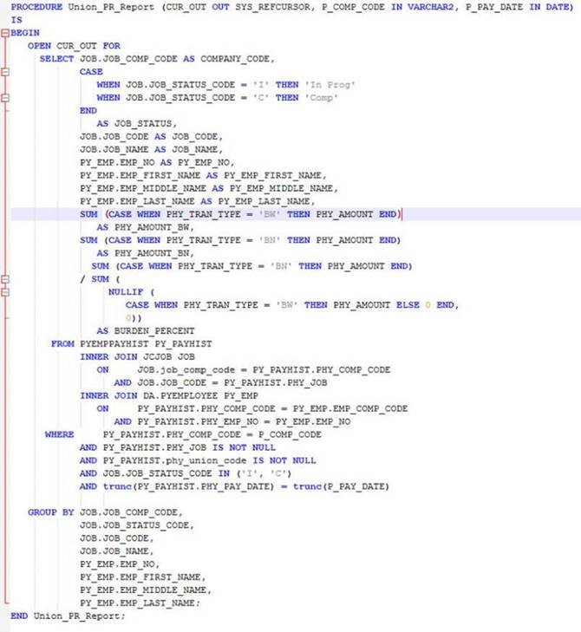

**What are your indications that stored procedure may be necessary:**

1. In CBS8.6, you’ll find stored procedure being called by the RDF which prepares the data and loads it in physical temporary table.  
      
   Do note, however, not because CBS8.6 calls stored procedure, it automatically means it is necessary. I’ve seen a report which calls stored procedure but it only performs several SELECT statements and dumps each resultset in the same temporary table. No data transformation. For this case, it is better to join the different SELECT statements and make that the data source directly in Jasper instead of calling a stored procedure. This takes out the unnecessary IO on DELETE/INSERT statements.
2. Complex data transformation needed to produce summary or analytical information
3. Data values are not directly fetched from the tables and requires other PL/SQL or stored procedure calls (example calling GET_AMOUNT to do currency conversion).

**Where to store procedures for reports:**

1. Procedure name should correspond to the report no.

|  |  |
| --- | --- |
| **CBS8.6 Report** | **CBS9 Stored Procedure** |
| GLA24 (Account Movements – Post Date) | Procedure **glara24** |

**Note:** *Report No. is converted by replacing the module code with the equivalent module code in CBS9 + r. All in lowercase characters.*

1. All stored procedure for a module should be placed in a common reports DB package named as <ModuleCode>_REPORTS (e.g. DEP_REPORTS for Deposits module). If package is not existing, create the package accordingly.